# CircleCI + Heroku

## 1.Connect CircleCI with Github

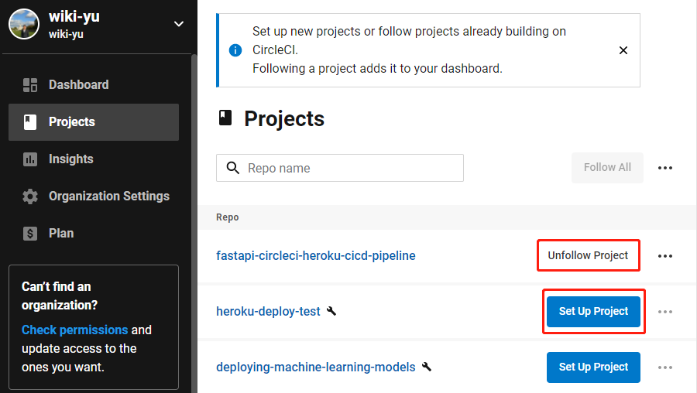

2. Connect CircleCI with Heroku

(1) Click “Project Setting” for the corresponding Github project.

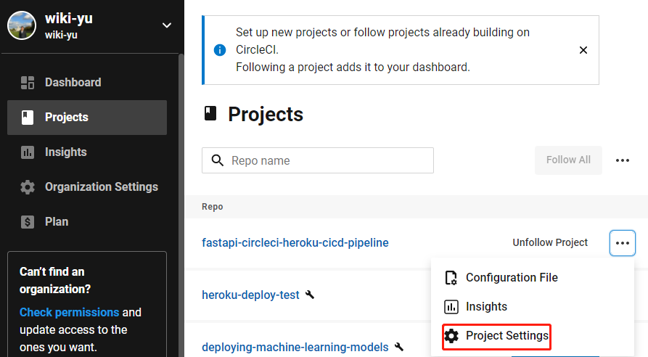

(2) Set up “Environment Variable” to connect CircleCI and Heroku

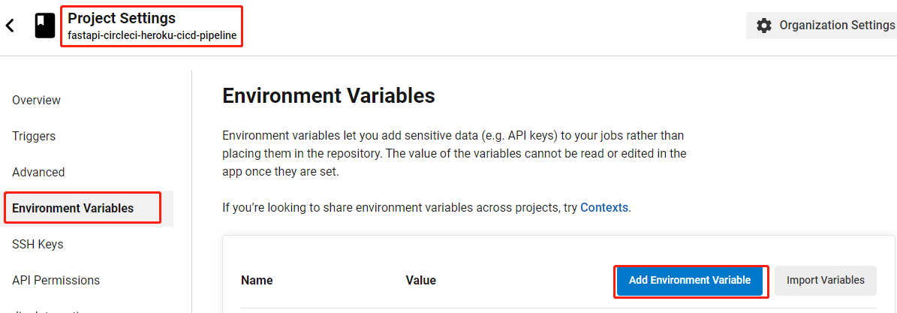

(3) The ENV name should match the one from the config.yml file. The value is obtained from the API key on Heroku.

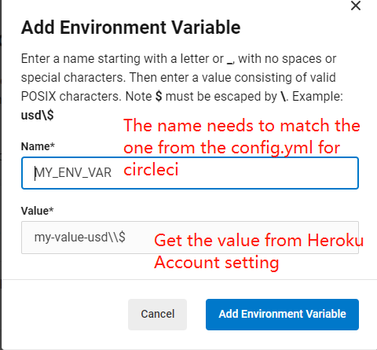

(4) Here is where to get the Heroku API key

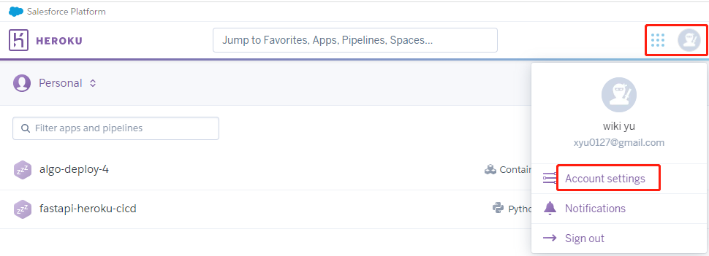



(5) Here is where to Set the ENV name.

